Deployment of Low-Cost Sensors for the Uintah Basin

Final Report

Prepared for:
Utah St. University – Bingham Research Center
320 N. Aggie Boulevard
Vernal, UT 84078

Under Purchase Orders P0433805-E and P0463046

Prepared by:
Eastern Research Group, Inc.
1600 Perimeter Park Dr., Suite 200
Morrisville, NC 27560

June 28, 2021

ERG Project Number: 4128.00.

This page is intentionally blank.

Contents
Page
1.0 Introduction and Overview 1-1
1.1 Project Motivation 1-1
1.2 Project Timeline 1-2
1.3 Organization of the Report 1-2
2.0 Review of Available Low-Cost VOC Sensors 2-1
2.1 Low-Cost Sensors Reviewed 2-1
2.2 Sensor(s) Selection 2-4
2.2.1 Lunar Outpost Canary-S 2-4
2.2.2 Dynament 2-5
3.0 Testing of Sensors and Deployment 3-7
3.1 Lunar Outpost Canary-S Sensor Unit 3-7
3.2 Dynament Combination Methane/Hydrocarbon Sensor Unit 3-9
3.3 Field Deployment 3-11
4.0 Data Reporting 4-1
4.1 Data Retrieval and Database Development 4-1
4.2 Data Distribution Statistics 4-2
4.3 Source Influence Evaluation 4-5
5.0 Observations 5-1
5.1 Methane and Total VOC Sensors 5-1
5.2 Laboratory Testing of Sensors 5-1
5.3 Concentration Data 5-1
6.0 Literature Search Results 6-1
Appendix A. Sensor and Meteorological Data
TABLES
Table 1-1. Tasks and Timeline 1-2
Table 2-1. Summary of Low-Cost Sensor Models Reviewed for this Study 2-2
Table 4-1. Data Fields in the Analysis Database 4-1
Table 4-2. Data Fields in the Analysis Database 4-2
Table 4-3. Summary of Concentrations for the Lunar Outpost and Dynament Sensorsª 4-3

FIGURES
Figure 2-1. Lunar Outpost Sensor 2-5
Figure 2-2. Dynament Sensor Box 2-6
Figure 3-1. Total VOC Concentrations from Bump Test 3-7
Figure 3-2. Methane Concentrations from Bump Test 3-8
Figure 3-3. Total VOC Concentrations from Source Test 3-8
Figure 3-4. Methane Concentrations from Source Test 3-8
Figure 3-5. Comparison of Total VOCs from the Lunar Outpost and the Sensit Sensor 3-9
Figure 3-6. Methane Concentrations from the 1% and 2.5% Methane Bump Tests 3-10
Figure 3-7. Methane Concentrations from the 100% Methane Bump Test 3-10
Figure 3-8. Horsepool Monitoring Station 3-11
Figure 4-1. Field Results of the Dyanment Sensor at Horsepool from 2/4/2020-3/31/2020 4-4
Figure 4-2. Field Results of the Lunar Outpost Sensor at Horsepool from 2/4/2020-3/31/2020 4-5
Figure 4-3. Location of the Horsepool Monitoring Station and Nearby Oil and Gas Wells 4-6
Figure 4-4. Dynament Methane Pollution Rose 4-7
Figure 4-5. Lunar Outpost Methane Pollution Rose 4-7
Figure 4-6. Lunar Outpost Total VOC Pollution Rose 4-8

Abbreviations/Acronym List
ASOS Automated Surface Observing System
CBM Coalbed methane
CEAS Cavity Enhanced Absorption Spectroscopy
CH4 Methane
CO Carbon monoxide
CO₂ Carbon dioxide
ERG Eastern Research Group, Inc.
HC Hydrocarbons
IR Infrared
MEMS Micro-electro mechanical system
MOX Metal Oxide
MSCF Thousand standard cubic feet
µg/m³ Micrograms per cubic meter
ND Non-detects
NDIR Non-dispersive Infrared
NO₂ Nitrogen dioxide,
O₃ Ozone
PID Photo-Ionization Detector
PM_{1.0} Particulate matter less than or equal to 1.0 micron in aerodynamic diameter
PM_{2.5} Particulate matter less than or equal to 2.5 microns in aerodynamic diameter
PM₁₀ Particulate matter less than or equal to 10 microns in aerodynamic diameter
ppb Parts per billion
ppm Parts per million
UDAQ Utah Division of Air Quality
VOC Volatile organic compounds

Introduction and Overview
This report documents the deployment of low-cost sensors for the Uintah Basin, including lessons learned and data analysis of the measurements during a short-term field study.
The State of Utah is home to complex topography, meteorology, mineral resources, large emission sources, and land use terrains that have created challenges for air quality management. The Utah State Legislature sets aside annually research funding for the “Science for Solutions” program to improve air quality. Topic areas are prioritized each year and are focused on Utah-specific air quality issues such as wintertime ozone, particulate matter less than or equal to 2.5 microns in aerodynamic diameter (PM_{2.5}), and emerging technologies.

Project Motivation
Recent studies of wintertime ozone pollution in the Uintah Basin have indicated that underestimation of organic compound emissions and inadequate organic compound speciation profiles in existing oil and gas emission inventories are the main reasons leading to underestimation of ozone concentrations simulated by photochemical models. The Uintah Basin contains nearly 11,000 active oil, gas, and coalbed methane (CBM) wells. In 2020, the basin produced over 26.0 million barrels (BBL) of liquids (oil/condensate), 224.0 million thousand standard cubic feet (MSCF) of gas (natural gas and associated gas), and 22.7 million MSCF of CBM gas.
Under “Goals and Priorities” for the 2020 Fiscal Year grant, Low-Cost Sensors were identified as an area of research needed to supplement ground-based air monitoring stations. New air monitoring technologies with increased spatial and temporal resolution have emerged in the last few years. The Utah Division of Air Quality (UDAQ) is interested in evaluating the sensors’ limitations and performance under environmental conditions, especially in oil and gas rich areas such as in the Uintah Basin.
Under Purchase Orders P0433805-E and P0463046 to the Bingham Research Center at Utah State University in Vernal, UT, Eastern Research Group, Inc. (ERG) researched, tested, and deployed low-cost sensors for total volatile organic compounds (VOCs) and methane (CH₄) to support this research goal. ERG developed several programmatic questions to guide this assessment:
- What are the available commercial low-cost total VOC and CH₄ sensors?
- What are the strengths and limitations of available commercial low-cost total VOC and CH₄ sensors?
- How do low-cost total VOC and CH₄ sensors perform under laboratory conditions?
- How do low-cost total VOC and CH₄ sensors perform under field conditions?
- Are the measurements from low-cost total VOC and CH₄ sensors pointing to anthropogenic emission sources?

Project Timeline
Table 1-1 presents the timeline for the project.
Table 1-1. Tasks and Timeline
Task | Timeline
Task 1 – Research low-cost VOC sensors | August 2019 – November 2019
Task 2 – Identify and purchase low-cost VOC sensors | November 2019 – December 2019
Task 3 – Testing low-cost VOC sensors | January 2020
Task 4 – Deploying low-cost VOC sensors | February 2020 – April 2020
Task 5 – Data Analysis | May 2020 – March 2021
Task 6 – Final Report | April 2021 – June 2021

Organization of the Report
This report is divided into six sections and 1 appendix.
- Section 1 introduces the purpose of this report.
- Section 2 presents an overview of low-cost VOC sensors researched and chronicles the identification and purchase of low-cost VOC sensors.
- Section 3 discusses the testing of low-cost VOC sensors under laboratory conditions and deployment in the field.
- Section 4 summarizes the measurements collected.
- Section 5 presents observations from the study.
- Section 6 presents the references from the literature survey.
- Appendix A presents the sensor measurements collected and hourly meteorological data from the nearest Automated Surface Observing System (ASOS) station.

Review of Available Low-Cost VOC Sensors
This section chronicles ERG’s efforts to identify available sensors for methane and total VOCs.
Low-cost sensors for criteria pollutants such as carbon monoxide (CO), nitrogen dioxide (NO₂), O₃, and PM_{2.5} sensors are commercially available and are used for air quality study applications nationwide.,, These non-regulatory sensors are used primarily to supplement traditional monitoring and are often placed in locations to assess community exposure or source influence.
While sensors are available for VOC and CH₄ for leak detection at industrial facilities, the concentration range effectiveness is not typically suitable for ambient air conditions. As such, low-cost sensors for VOC and CH₄ for ambient air conditions are not as widely available compared to the above criteria pollutant sensors.

Low-Cost Sensors Reviewed
At project initiation, ERG performed a literature search, surveyed the sensor market via the internet for commercially available and updated sensor products, interviewed manufacturers, and reviewed information from South Coast’s Air Quality Sensor Performance Evaluation Center (AQ-SPEC) and EPA guidance documents to identify and rank VOC and methane sensors for potential consideration. Initially, the focus of the project was to deploy multiple sensors at multiple locations in the Uintah Basin.
The literature search using Proquest Agricultural and Environmental database services yielded nearly 50 peer-reviewed journal articles for the years 2012 to 2019 using search terms which provided useful information on the sensor-types and products used for methane and VOC detection. Table 2-1 presents the VOC and CH₄ sensors chosen from the literature review and were commercially that were reviewed and available, as of September 2019. Data presented include: sensor manufacturer/model; pollutant(s); sensor type; detection range, and approximate cost. Specific considerations for sensor selection include:
- Low-cost (< $500)
- Low-power (<12 volts)
- Low detection levels suitable for ambient conditions
- Continuous measurements (a minute or less)
- Commercially-available
- Economically feasible
Table 2-1. Summary of Low-Cost Sensor Models Reviewed for this Study
Sensor Manufacturer (Model) | Pollutant(s)ª | Sensor Type^{b} | Detection Range | Cost  ($)
Aeris (MIRA PICO LDS) | CH₄ | IR | 0.1-10,000 ppm | $350
Aeroqual (AQS 65) | Total VOCs | PID | 0.1-20 ppm | $1,500
Aeroqual (Series 500) | CH₄ | MOX | 0-100 ppm | $1,250
Alphasense (AH2) | Total VOCs | PID | 1-50 ppbv | $700
Alphasense LTD (IRM-AT) | CH₄ | MOX | 0-2.5% | $1.00
Alphasense LTD (MMO VOC) | Total VOCs | MOX | 1-100 ppm | Need quote
Applied Sensor AMS (iAQ-Core C) | Total VOCs | MOX | 125-600 ppbv | $20
Baseline-Mocon (Series 9000 Total HC) | CH₄ | MOX | 1-2000 ppm | Need quote
Baseline-Mocon (VOC-Traq) | Total VOCs | PID | 0.1-2,000 ppm | $215
City Technology (IR-CelCH4) | CH₄ | IR | 0-5% | $585
City Technology (Micropel 75M) | CH₄ | IR | 0-3% | $157
CrowCon (Laser Methane Mini) | CH₄ | NDIR | 0-100% | $1,700
Dynament (MSH2ia-LS/HC/CO₂) | CH₄, CO₂ | IR | 0.01-5% | $100
Dynament (MSH2-LP/HC) | CH₄, CO₂ | IR | 0.01-5% | $100
Edinburgh Sensors (Gascard CH₄) | CH₄ | NDIR | 300-10,000 ppm | $2,000
Figaro Engineering (TGS-2600) | CH₄ | MOX | 7-100 ppm | $16
Figaro Engineering (TGS-2611) | CH₄ | MOX | 500-10,000 ppm | $50
Figaro Engineering (TGS-2612) | CH₄ | MOX | 500-10,000 ppm | $50
Figaro Engineering (TGS-6812) | CH₄ | MOX | 0-14,000 ppm | $50
Figaro Engineering (TGS-8100) | CH₄ | MOX | 10-100 ppm | $20
FIS (SB-11A-00) | CH₄ | MOX | 300-10,000 ppm | No response
FIS (SB-12A) | CH₄ | MOX | 500-10,000 ppm | No response
Foobot (FBT0002100) | Total VOCs | MOX | 125-1,000 ppb | $200
Futurelec (MQ-4) | CH₄ | MOX | 300-10,000 ppm | $4.00
GDS (Gasmax) | CH₄ | NDIR | 1-100% | $3,200
GDS Corp (GDS-48) | Total VOCs, CH₄, CO₂ | PID | 0-300 ppm | $1,000
GDS Corp (GDS-IR) | CH₄ | NDIR | 0.1-100% | $1,000
GDS Corp (GDS-IR, Gasmax) | CH₄, HC | IR | 0.1-100% | $3,000
Graywolf (Directsen Sen-B TVOC) | Total VOCs | PID | 0.1-10,000 ppm | $1,000
Hanwei Electronics (MQ4) | CH₄ | MOX | 300-10,000 ppm | No response
Hubei Cubic-Ruiyi Instrument Co. (Portable Gas 3100P) | CH₄ | NDIR | 0-10% | No response
IDT (SGA711) | CH₄ | MOX | 10-10,000 ppm | $30
IDT (ZMOD4410) | Total VOCs, CO₂ | MOX | 0.1-100% | $150
IBM (APRA) | CH₄ | laser | 5-25 ppb | $300
Ion Science (Falco Fixed VOC Detector) | Total VOCs | PID | 0.01-500 ppm | $1,000
Ion Science (MiniPID2) | Total VOCs | PID | 0.005-100 ppm | $1,400
Ion Science (Tiger Handheld VOC Detector) | Total VOCs | PID | 0.1-100% | $4,212
Ion Science (TVOC Fixed Detector) | Total VOCs | PID | 0.1-100% | $3,000
Ion Science (Typhoon) | Total VOCs | PID | 0-1,000 ppm | No response
KWJ Engineering (MEMS Nanosensor) | CH₄ | MEMS | 0-5% | No response
LI-COR (LI-7810) | CH₄ | CEAS | 0-100 ppm | $10,000
LOSANT (Canary) | CH₄ | NDIR | 0-5% | $200
LOSANT (Canary) | Total VOCs | PID |  | $200
Lunar Outpost (Canary-S) | Total VOCs, CH₄ | PID | 0.001-40 ppm | $2,755
Maxion Technologies (APRA) | CH₄ | IR | 5-25 ppb | $10,000
Nemoto (NCP-180S-7S) | CH₄ | Pellistor | 0-100% | $30
Nova (470 Series) | CH₄ | NDIR | 0.1-100% | No response
Quanta3 | CH₄ | IR | 5-25 ppb | $3,000
RAE (UltraRAE 3000) | Total VOCs | PID | 0.10-100% | $5,000
Renesas Electronic Corp. | CH₄ | MOX | 10-10,000 ppm | $362
Safe Core Radius (Radius BZ1) | CH₄ | MOX | 0.10-100% | $4,000
Sensortech (MP-7217) | CH₄ | Pellistor | 0.10-100% | $50
Sensortech/GSX (INIR) | CH₄ | NDIR | 4-10% | $233
Sensortech/GSX (IR12 Series) | CH₄ | NDIR | 0-100% | $172
Sensortech/GSX (IR15TT-R) | HC, CO₂ | NDIR | 0.1-100% | $260
Sensortech/GSX (NGM) | CH₄ | Pellistor | 4-100% | $32
Sensortech/GSX (VQ21TB) | CH₄ | Pellistor | 0-3% | $50
Siemens (Ultramet 23 Analyzer) | CH₄ | NDIR | 1-100% | $1,500
UniTec (Sens-It) | CH₄, | MOX | 1-1,500 ppm | $2,200
UniTec (Sens-It) | Total VOCs | PID | 0-15 ppm | No response
UST Umwelt (Sensortechnik) | CH₄, CO₂ | MOX | 10-10,000 ppm | No response
Winsen (GM-402B) | CH₄ | Pellistor | 1-1,000 ppm | $30
Winsen (MP-4) | CH₄ | Pellistor | 300-10,000 ppm | $16
Xi’an Dingyan Technology Co. (DY-Gas Analyzer) | CH₄ | NDIR | 1-100% | $5,000
ª CO₂ = carbon dioxide; HC = hydrocarbons
^{b} CEAS = Cavity Enhanced Absorption Spectroscopy; IR = Infrared; MEMS = Micro-electro mechanical system; MOX = Metal Oxide; NDIR = Non-dispersive Infrared; Pellistor = gas system; PID = Photo-Ionization Detector;

Sensor(s) Selection
ERG developed an initial matrix of sensors for CH₄ and Total VOCs based on various parameters and attempted to contact manufacturers which met the selection criteria. Several lessons were gleaned from this exercise:
- While many of the websites did not list prices for the sensors, that information was available only after contacting the manufacturer.
- Sensor prices typically only cover the sensor. Additional costs for housing, communication, data analytics, shipping, and other features tended to increase the price. In some cases, pricing information was not available.
- Some of the identified sensors were not commercially available and would often take weeks to months before delivery.
- Many of the sensor concentration ranges were not low enough for ambient conditions.
- Data ownership is not always apparent.
The technologies for low-cost methane and VOC sensors are still lagging behind other pollutant sensors. As such, the current array of these pollutants was limited. We have identified two sensors, both of which were over the proposed budget per sensor. As such, ERG requested and was approved to reduce the number of sensors for purchase, testing, and deployment. Two sensors were purchased for testing and deployment.

Lunar Outpost Canary-S
In November 2019, ERG ordered a Canary-S Special Order combination methane and total VOC sensor. The timeframe from order to delivery was approximately 2 weeks. The Canary-S sensor box has options for inclusion of multiple parameters. ERG chose the following parameters for the sensor box:
- Methane
- Total Volatile Organic Compounds
- PM₁, PM_{2.5}, and PM₁₀
- Outdoor pressure
- Internal temperature and relative humidity
Figure 2-1 presents the sensor box and companion solar power unit. The total sensor box, with monthly data plan, cost $2,855.
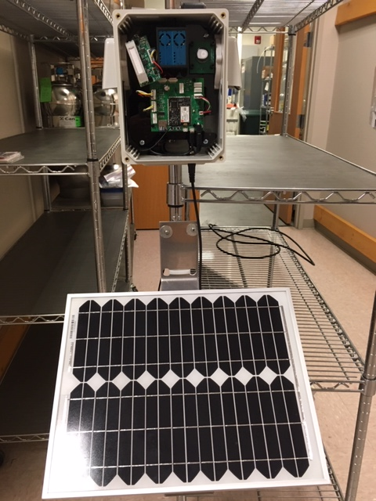
Figure 2-1. Lunar Outpost Sensor

Dynament
In December 2019, ERG ordered a Dynament combination methane/speciated hydrocarbon sensor. The timeframe from order to delivery was approximately 1 week. The Dynament sensor box has options for inclusion of multiple parameters. ERG chose the following parameters for the sensor box:
- Methane
- Total Hydrocarbons
- Outdoor temperature
- Detector, reference, and absorbance signals
Figure 2-2 presents the sensor box. The total sensor box, with housing and data packaging, cost $585.
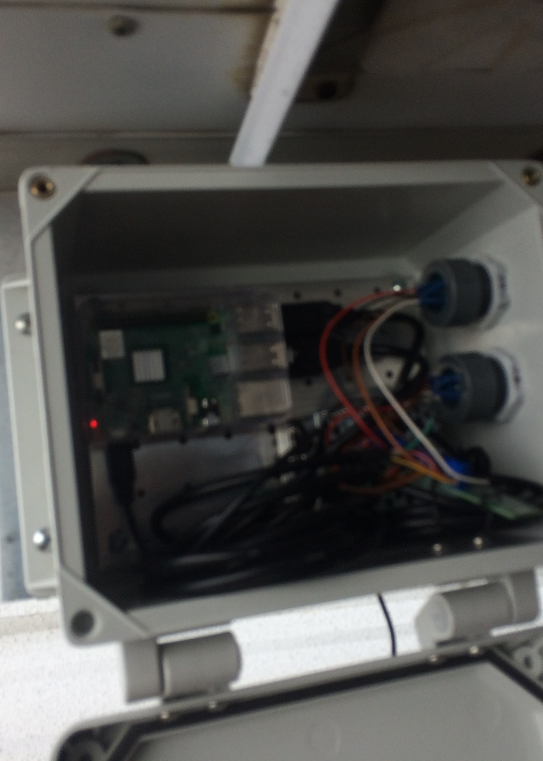
Figure 2-2. Dynament Sensor Box

Testing of Sensors and Deployment
This section describes the laboratory tests performed by ERG to test the Lunar Outpost Canary-S sensor and Dynament sensor units for deployment.
As part of this study, ERG performed field tests for each sensor box at its Morrisville, NC laboratory. Two types of tests were conducted for the Lunar Outpost Canary-S sensor unit:
- “Bump” test where a known concentration is released near the sensor to test sensor accuracy and responsiveness.
- “Source” test where the sensor is placed near an idling truck for 20 minutes.
For the Dynament sensor unit, only a “bump” test was performed due to time constraints.

Lunar Outpost Canary-S Sensor Unit
In early December, ERG conducted a bump test and a source test to evaluate the responsiveness to direct anthropogenic sources. The bump test consisted of exposing the sensor to a canister of 500 ppb concentration of isobutylene for three 1-minute bursts of 11:39am, 11:44, and 11:49. Figure 3-1 presents the results of the total VOC concentrations.
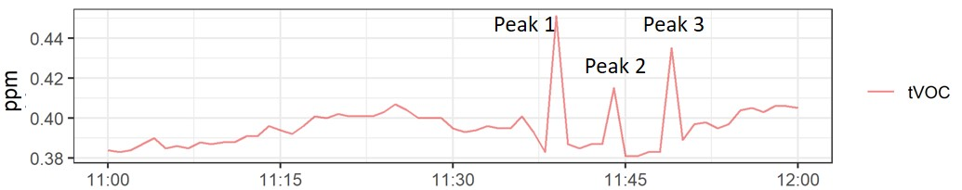
Figure 3-1. Total VOC Concentrations from Bump Test
As presented in Figure 3-1, the results of the bump test indicate good responsiveness of the total VOC sensor, in terms of peak identifications related to exposure of the bump tests. In terms of magnitude, the first peak was roughly 460 ppb, which is close to the 500 ppb isobutylene concentration. Peak #3 measured at 430 ppbv, while Peak #2 measured at 415 ppbv.
Figure 3-2 presents the results of the methane concentrations.
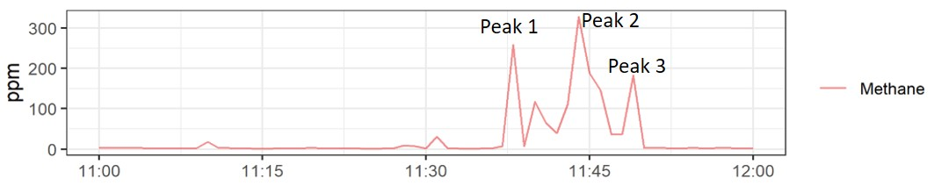
Figure 3-2. Methane Concentrations from Bump Test
As presented in Figure 3-2, the results of the bump test indicate good responsiveness of the methane sensor, in terms of peak identifications related to exposure of the bump tests.
For the source test, ERG ran a Ford F150 in idle for 20 minutes. Figure 3-3 presents the results of the total VOC concentrations.
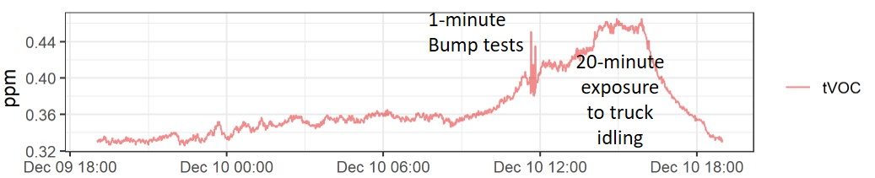
Figure 3-3. Total VOC Concentrations from Source Test
As presented in Figure 3, the results of the source test indicate good responsiveness of the total VOC sensor, in terms of peak identifications related to exposure of the truck idling. In terms of magnitude, the peaks were consistent for the entire 20 minutes, roughly at 480 ppb. When the vehicle shut down, the total VOC concentrations began to decrease.
Figure 3-4 presents the results of the methane concentrations.
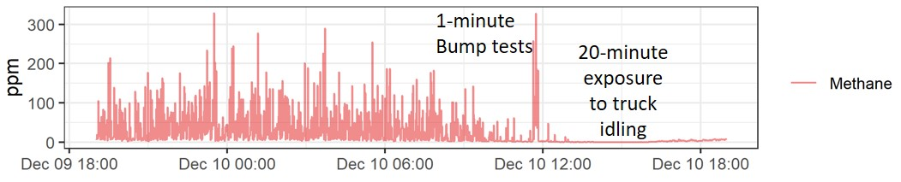
Figure 3-4. Methane Concentrations from Source Test
As presented in Figure 3-4, the results of the source test indicate no responsiveness of the methane sensor, as no peaks were observed. This is somewhat surprising and was worthy of additional investigations. In summary, the total VOC sensor showed good responsiveness to the bump test and the source test. Additionally, the methane sensor showed good responsiveness to the bump test, but not the source test.
ERG also compared the Lunar Outpost data concurrently with a Sensit Sensor that ERG is testing for another project. The Sensit Sensor is roughly priced at $8,000 per unit. Figure 3-5 compares the total VOC concentrations between the two sensors.
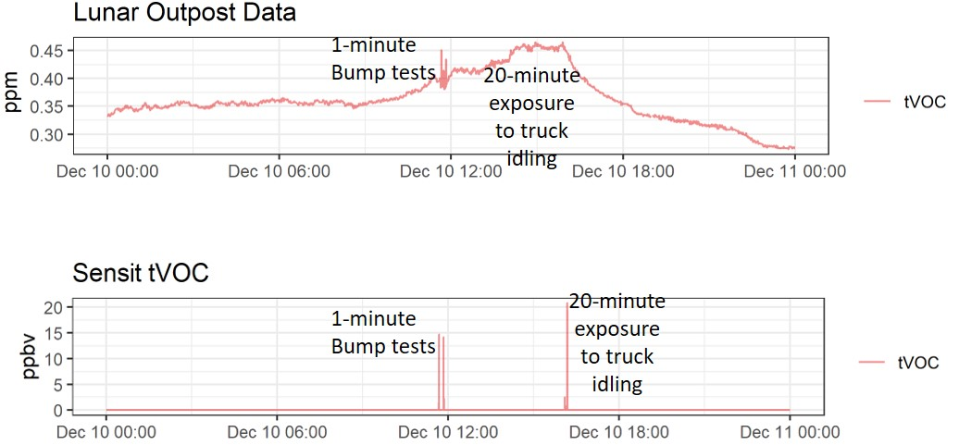
Figure 3-5. Comparison of Total VOCs from the Lunar Outpost and the Sensit Sensor
As presented in Figure 3-5, the results of the identification and magnitude of peaks are in good agreement. However, the baseline values for the Lunar Outpost sensor are much higher than the Sensit sensor, roughly 0.35 vs. close to 0. This is due to the method detection limit of the Sensit sensor being lower than the Lunar Outpost sensor.

Dynament Combination Methane/Hydrocarbon Sensor Unit
Testing of the Dynament Sensor Unit was delayed until January 2020, as additional parts were needed from the manufacturer when the original sensor arrived in December 2019.
In late January, ERG conducted a bump test to evaluate the methane responsiveness to low and high known concentrations of methane (1%, 2.5%, and 100%). The bump test consisted of five-minute bursts at 10.39am, 10:44am, and 10:50am. Figure 3-6 presents the results of the methane concentrations for the 1% and 2.5% methane bump tests, respectively.
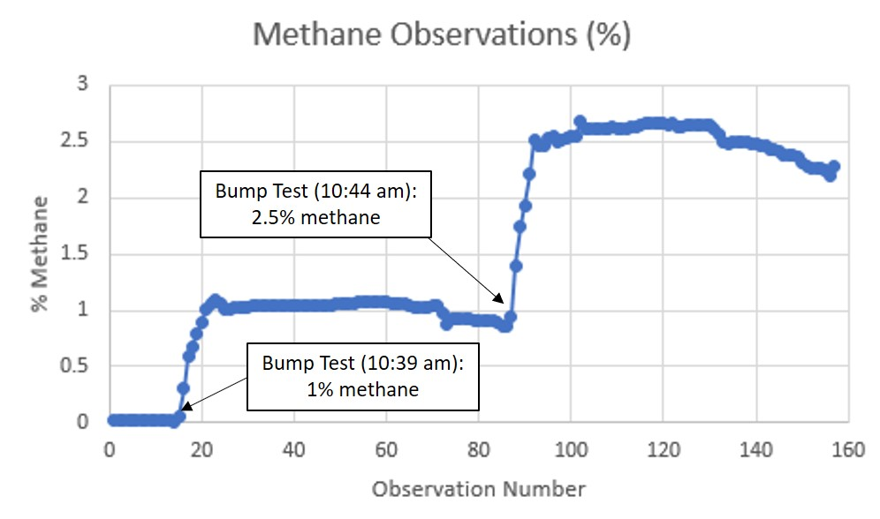
Figure 3-6. Methane Concentrations from the 1% and 2.5% Methane Bump Tests
As presented in Figure 3-6, the results of the bump test indicate good responsiveness of the total methane sensor, in terms of peak identifications related to exposure of the low-level methane bump tests. In terms of magnitude, the peaks were detected shortly after the known concentrations were injected.
Figure 3-7 presents the results of the methane concentrations for the 100% methane bump test.
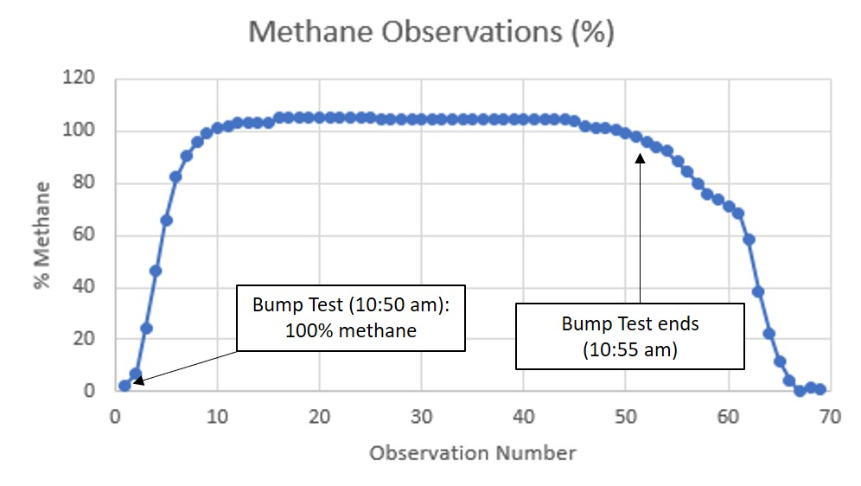
Figure 3-7. Methane Concentrations from the 100% Methane Bump Test
As presented in Figure 3-7, the results of the bump test indicate good responsiveness of the total methane sensor, in terms of peak identifications related to exposure of the high-level methane bump test. In terms of magnitude, the peaks were detected shortly after the known concentrations were injected.
In summary, the methane sensor showed good responsiveness to the bump test in terms of magnitude and duration.

Field Deployment
After testing of the sensor units, ERG shipped them to Utah for deployment. An ERG staff member residing in Utah met with the BRC staff to set-up the sensors at the Horsepool Monitoring Station (coordinates = 40.1437, -109.4672), as presented in Figure 3-8.
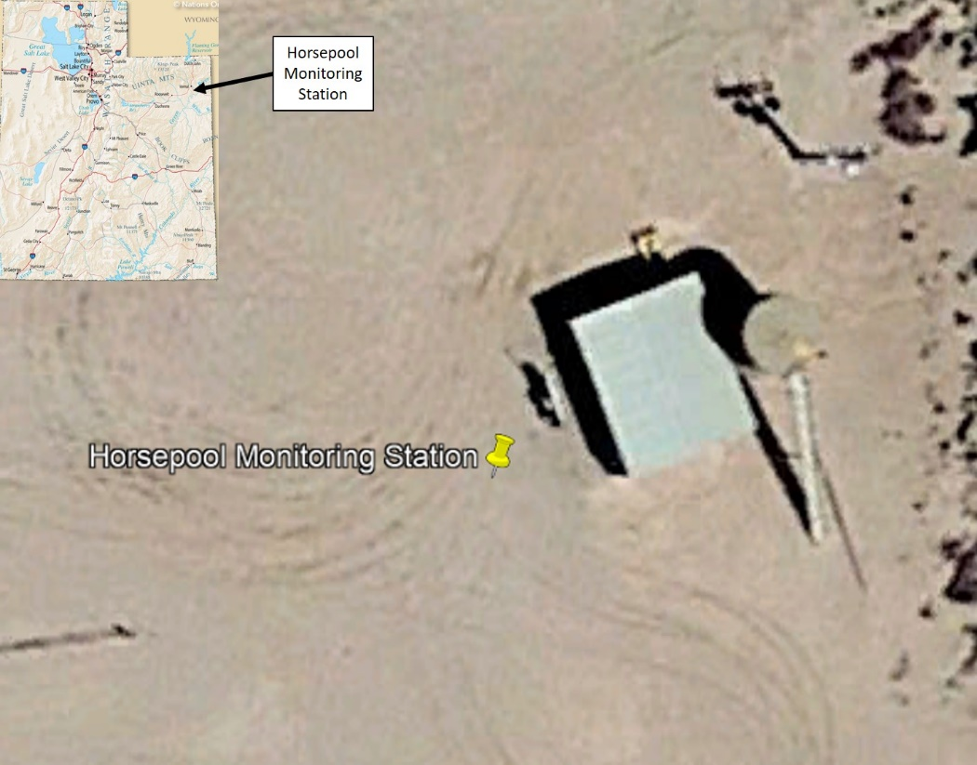
Figure 3-8. Horsepool Monitoring Station
Setup at the monitoring station was completed on February 4, 2020, as the sensor units were attached to tripods, hooked up to the monitoring site WiFi, and began taking measurements and streaming data.
This page is intentionally blank.

Data Reporting
This section describes the reporting of the measurements and compilation of the data into a master database.
Sampling at the Horsepool monitoring station began on 2/4/2020 and continued through 3/31/2020. The sensor deployment coincided with other field activities conducted by BRC staff related to this project.

Data Retrieval and Database Development
Minute-level measurements from the Lunar Outpost Canary-S sensor were transmitted wirelessly to Lunar Outpost’s data portal. This data was retrieved daily via the subscription that ERG purchased. The downloaded raw file was merged into a master database, which was then QA’d and standardized into an analysis data table. In total, over 81,000 data records from the Canary-S sensor were obtained.
Five second measurements from the Dynament sensor were stored within the Raspberry Pi unit and daily files were e-mailed to ERG staff. The daily raw files were merged into a master database, which was then QA’d and standardized into an analysis data table. In total, over 764,000 data records from the Dynament sensor were obtained.
The analysis database consists of ten data fields, and these are presented in Table 4-1. Primary keys are denoted by the “*”. The use of primary keys ensures no duplication of data and mitigates record growth. Appendix A-1 presents the measurements in Microsoft Excel.
Table 4-1. Data Fields in the Analysis Database
Field Name | Field Description
SENSOR_NAME* | Name of the Sensor
SAMPLE_DATE* | Date for when the measurement begins
START_TIME* | Start time for when the measurement begins
SAMPLE_DURATION | Duration of the measurement value
PARAMETER* | Description of the measurement parameter
VALUE_REPORTED | Concentration of the sensor measurement
UNIT | Unit of measure for the parameter
VALUE_ADJUSTED | Concentration value, adjusted after negatives were removed
NULL_FLAG | Flag to identify invalidated data records
ND_FLAG | Flag to identify a non-detect
The closest National Weather Service (NWS) Automated Surface Observing System (ASOS) station is in Vernal, Utah, which is 21 miles north of the Horsepool monitoring station. Hourly wind observations from this site, VEL (40.44092, -109.50992), was obtained for the study period. The data fields for the hourly measurements are presented in Table 4-2.
Table 4-2. Data Fields in the Analysis Database
Field Name | Field Description
METEOROLOGICAL_STATION* | Name of the meteorological station
STATION_ID | Station ID
OBSERVATION_DATE* | Date of observation
OBSERVATION_HOUR* | Hour of observation
WIND_SPEED | Wind speed in miles per hour
WIND_DIRECTION | Wind direction in degrees from north
NULL_FLAG | Flag to identify null values
Appendix A-2 presents the hourly observations in Microsoft Excel.

Data Distribution Statistics
Table 4-3 presents a comparison of the methane and total VOC concentrations from each sensor unit at the Horsepool monitoring station. The percent completeness ranged from 81.40% for the Lunar Outpost methane sensor to 100% for the Lunar Outpost total VOC sensor. Of note is that the methane concentrations amongst the two sensors was not close, in terms of average and percentiles.
Table 4-3. Summary of Concentrations for the Lunar Outpost and Dynament Sensorsª
Pollutants | Sensor | Units | # Concentrations | % Detections | Arithmetic Meanª | Percentile Value^{c}
 |  |  |  |  |  | 5th | 10th | 25th | 50th | 75th | 90th | 95th
Methane | Lunar Outpost | PPM | 82,224 | 81.40% | 298.05 ± 2.01 | 0 | 0 | 11.28 | 225.22 | 507.83 | 713.26 | 817.35
 | Dynament |  | 748,542 | 94.95% | 625.38 ± 0.76 | 0 | 100 | 400 | 600 | 800 | 1,100 | 1,300
Propane | Dynament | PPM | 739,468 | 99.15% | 461.51 ± 0.57 | 0 | 200 | 300 | 400 | 600 | 900 | 1,000
Total VOCs | Lunar Outpost | PPM | 82,224 | 100.00% | 0.260 ± 0.01 | 0.105 | 0.120 | 0.153 | 0.216 | 0.376 | 0.454 | 0.471
ª In calculations involving non-detects (ND), ERG used a value of zero.

Figure 4-1 presents field results of the Dynament sensor for methane and propane. Over 739,000 measurements for each pollutant were generated.
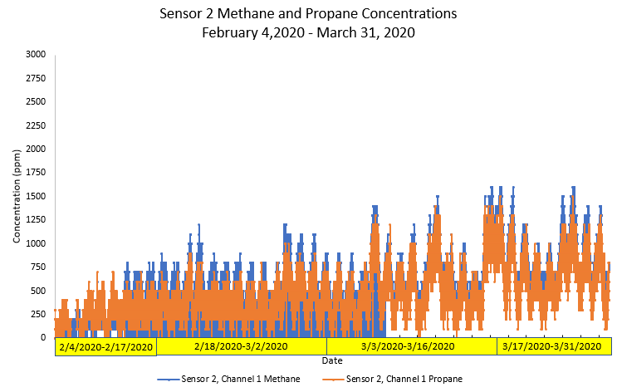
Figure 4-1. Field Results of the Dyanment Sensor at Horsepool from 2/4/2020-3/31/2020
The propane and methane concentrations trended very well together.
Figure 4-2 presents field results of the Lunar Outpost sensor for methane and total VOCs. Over 82,000 measurements for each pollutant were generated. Note that for ease of viewing, the total VOC data are plotted on a much lower scale.
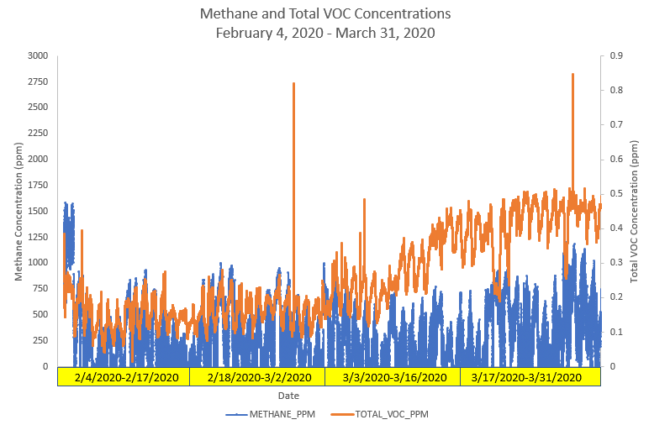
Figure 4-2. Field Results of the Lunar Outpost Sensor at Horsepool from 2/4/2020-3/31/2020
The methane and propane concentrations tended to track well together.

Source Influence Evaluation
The sub-hourly measurements were averaged to hourly averages and then paired with hourly wind observations from the VEL NWS station. The area around the Horsepool monitoring station is surrounded by oil and natural gas wells, as presented in Figure 4-3.
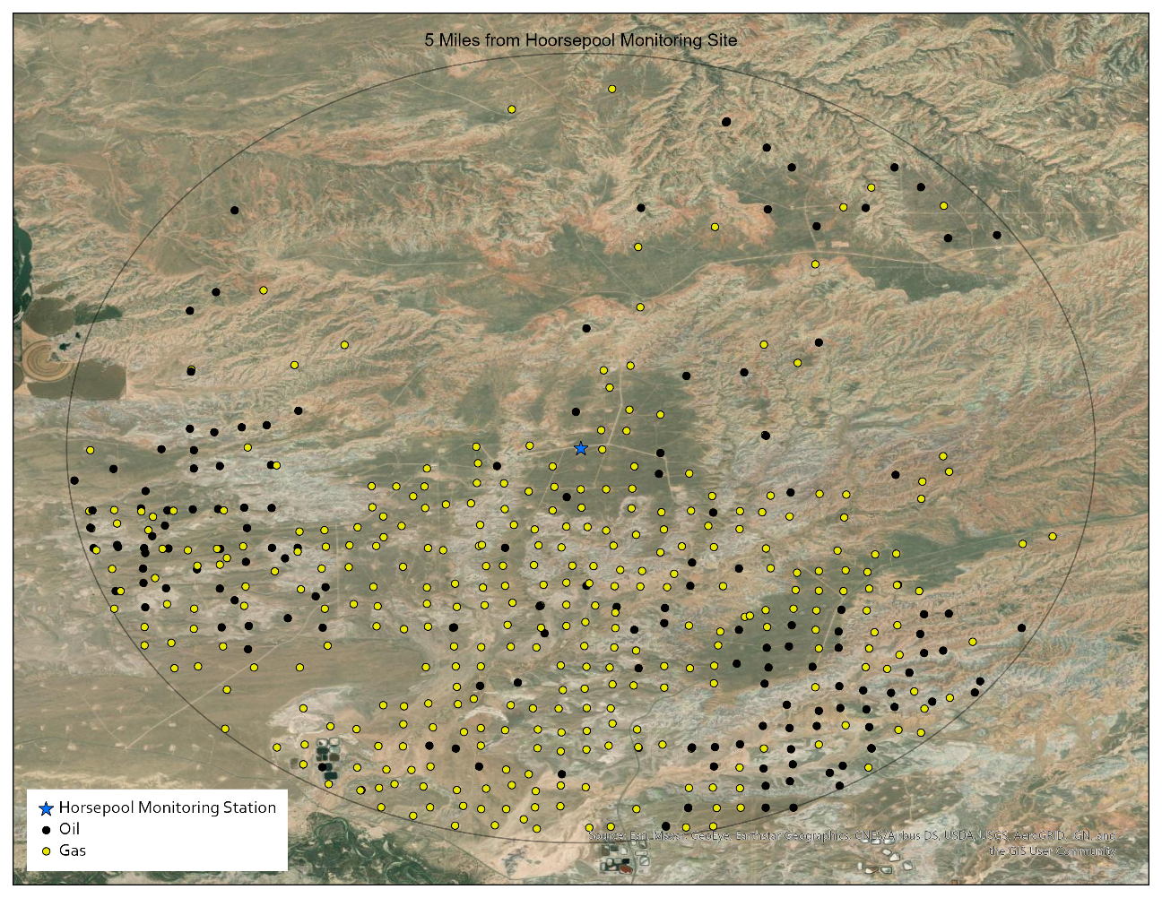
Figure 4-3. Location of the Horsepool Monitoring Station and Nearby Oil and Gas Wells
Pollution roses, which are concentrations plotted against the wind direction, are presented in Figures 4-4 through 4-6. Figure 4-4 is the methane pollution rose for the Dynament sensor, while Figure 4-5 is the methane pollution rose for the Lunar Outpost sensor. Both pollution roses show clusters to the west and east of the monitoring station, which reflects dense locations of oil and gas wells.
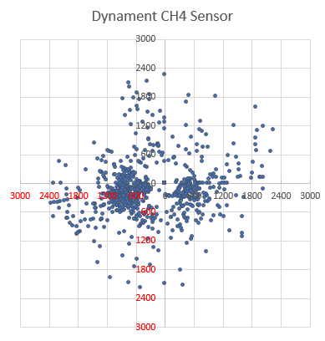
Figure 4-4. Dynament Methane Pollution Rose

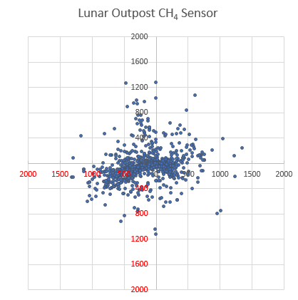
Figure 4-5. Lunar Outpost Methane Pollution Rose

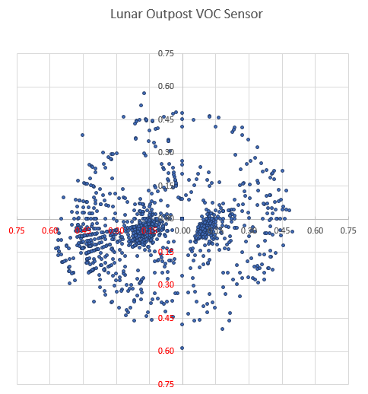
Figure 4-6. Lunar Outpost Total VOC Pollution Rose
The VOC pollution rose pattern is similar to the methane pollution roses, but larger concentrations are coming from the east to east-southeast.

Observations
This section summarizes the observations of this study.

During this study, several observations and lessons learned were gleaned. Each observation is placed under general groupings for organization.

Methane and Total VOC Sensors
- Observation – Methane and total VOC sensors were commercially available.
- While over 60 sensors/sensor units were identified in this study, only 2 were selected for laboratory testing and field deployment.
- Many of the identified sensors did not have published detection ranges applicable to ambient-level conditions.
- By comparison, ozone, CO, and PM sensors are more readily-available and more easily commoditized from purchase to delivery.
- Observation – Information for commercially-available sensors was not always complete and/or accurate.
- Information needed on the technical specification to assess the viability of sensors often required additional research and direct communication with the vendors.
- The sensors ranged from build-it-your-own type sensor systems to turn-key systems.
- Costing information for certain sensors was not consistent and was not complete as “add-ons” increased the advertised price.
- Many of the commercially-available sensors often had lead times of 4-6 weeks from purchase to delivery.

Laboratory Testing of Sensors
- Observation – The Lunar Outpost and Dynament sensors performed well during laboratory testing.
- For both sensors, ERG tested against known concentrations, and both sensors responded well in terms of responsiveness, magnitude, and duration.
- The Lunar Outpost sensor was tested against an emissions sources, and responded well in terms of responsiveness, magnitude, and duration.

Concentration Data
- Observation – The performances of the Lunar Outpost and Dynament sensors were of mixed results.
- Surprisingly, the percent detection rate for the Lunar Outpost methane sensor was less than 82%. Other detection rates were greater than 94%.
- While the methane concentrations for both sensors were not similar in magnitude, they did exhibit similarities in identifying peaks.
- Our field tests showed that while these sensors are generally good for detecting CH₄ concentrations at source, they are not suitable to capture the lower ambient level of CH₄ concentrations in Uinta Basin.
- Observation – Integration of concentration data and wind direction confirm the presence of oil and gas wells surrounding the Horsepool monitoring station.
  - The ubiquitous locations of oil and gas wells are reflected in the pollution roses.
  - Higher methane and total VOC concentrations were higher in more dense areas of oil and gas wells to the east and east-southeast of the Horsepool monitoring station.

Literature Search Results
- Akamatsu, T. I. T., Tsuruta, A., & Shin, W. (2017). Selective Detection of Target Volatile Organic Compounds in Contaminated Humid Air Using a Sensor Array with Principal Component Analysis. Sensors (Basel), 17(7). doi:10.3390/s17071662.
- Aleixandre, Manuel and M Gerboles., (2012) Review of Small Commercial Sensors for Indicative Monitoring of Ambient Gas., Chemical Engineering Transactions, 30: 1-7.
- Alquaity, A. B. S., Al-Saif, B., & Farooq, A. (2018). A widely-tunable and sensitive optical sensor for multi-species detection in the mid-IR. Measurement Science and Technology, 29(1), 9. doi:10.1088/1361-6501/aa912b.
- Andersson, M., Bastuck, M., Huotari, J., Spetz, A. L., Lappalainen, J., Schütze, A., & Puglisi, D. (2016). SiC-FET Sensors for Selective and Quantitative Detection of VOCs Down to Ppb Level. Procedia Engineering, 168, 216-220. doi:https://doi.org/10.1016/j.proeng.2016.11.165.
- Arroyo, P., Herrero, J. L., Suárez, J. I., & Lozano, J. (2019). Wireless Sensor Network Combined with Cloud Computing for Air Quality Monitoring. Sensors, 19(3), 691.
- Axen, Hanna. (2016) "Methane Flux Measurements with low-cost solid state sensors in Kobbefjord, West Greenland, Master degree thesis, Dept of Physical Geography and Ecosystem Science, Lund University, Sweden, 2016.
- Azzouz, A. (2019). Advances in colorimetric and optical sensing for gaseous volatile organic compounds. In TrAC Trends in Analytical Chemistry, 118, 502-516,https://doi.org/10.1016/j.trac.2019.06.017.
- Cai, Tiodon, Guangzhen Gao and Minrui Wang., (2016) Simultaneous detection of atmospheric Ch4 and CO using a single tunable multi-mode diode laser at 2.33 um., Optics Express 859.
- Cheng, S., Wang, G., Lang, J., Wen, W., Wang, X., & Yao, S. (2016). Characterization of volatile organic compounds from different cooking emissions. Atmospheric Environment, 145, 299-307. doi:https://doi.org/10.1016/j.atmosenv.2016.09.037.
- Cho, S.-Y., Koh, H.-J., Yoo, H.-W., Kim, J.-S., & Jung, H.-T. (2017). Tunable volatile-organic-compound sensor by using Au nanoparticle incorporation on MoS2. ACS sensors, 2(1), 183-189.
- Collier-Oxandale, A. M. Thorson, J., et. al., Mechanical Engineering, U. o. C., Boulder, CO80309, USA. (2019). Understanding the ability of low-cost MOx sensors to quantify ambient VOCs. Atmospheric Measurement Techniques, 12(3), 1441-1460. doi:https://doi.org/10.5194/amt-12-1441-2019.
- Collier-Oxandale, A., Casey, J. G., Piedrahita, R., Ortega, J., Halliday, H., Johnston, J., & Hannigan, M. P. (2018). Assessing a low-cost methane sensor quantification system for use in complex rural and urban environments. Atmospheric Measurement Techniques, 11(6), 3569-3594. doi:10.5194/amt-11-3569-2018.
- Embiale, A., Zewge, F., Chandravanshi, B.S. et al., (2019), Commuter exposure to particulate matters and total volatile organic compounds at roadsides in Addis Ababa, Ethiopia. Int. J. Environ. Sci. Technol. 16, 4761–4774. https://doi.org/10.1007/s13762-018-2116.
- Eugester, W. (2012). Performance of a low-cost methane sensor for ambient concentration measurements in preliminary studies. Retrieved from https://www.atmos-meas-tech.net/5/1925/2012/amt-5-1925-2012.pdf.
- Fox, T. A. (2019). A review of close-range and screening technologies for mitigating fugitive methane emissions in upstream oil and gas - IOPscience. Environmental research Letters, 14(5). doi:doi:10.1088/1748-9326/ab0cc3.
- Fu, L., Huda, Q., Yang, Z., Zhang, L., & Hashisho, Z. (2017). Autonomous mobile platform for monitoring air emissions from industrial and municipal wastewater ponds. J Air Waste Manag Assoc, 67(11), 1205-1212. doi:10.1080/10962247.2017.1285832.
- Garcia-Gonzales, D. A. (2019). Associations among particulate matter, hazardous air pollutants and methane emissions from the Aliso Canyon natural gas storage facility during the 2015 blowout. In O. Poppoola (Ed.): Environment International.
- Honeycutt, W. T., Ley, M. T., & Materer, N. F. (2019). Precision and Limits of Detection for Selected Commercially Available, Low-Cost Carbon Dioxide and Methane Gas Sensors. Sensors (Basel), 19(14). doi:10.3390/s19143157.
- James J. Scherer, "Next Generation Laser-Based Natural Gas Leak Detection" EPA STAR 10/17/2017 (powerpoint) https://www.epa.gov/sites/production/files/2017-11/documents/16.scherer.aeris_2017aiw.pdf.
- Kumar, P., Kim, K.-H., Mehta, P. K., Ge, L., & Lisak, G. (2019). Progress and challenges in electrochemical sensing of volatile organic compounds using metal-organic frameworks. https://doi.org/10.1080/10643389.2019.1601489. doi:181723166.
- Lewis, A. C. (2019). Low-cost sensors for the measurement of atmospheric composition: overview of topic and future applications. Retrieved from http://eprints.whiterose.ac.uk/135994/1/WMO_Low_cost_sensors_post_review_final.pdf.
- Lewis, A. C., Lee, J. D., Edwards, P. M., Shaw, M. D., Evans, M. J., Moller, S. J., . . . White, A. (2016). Evaluating the performance of low cost chemical sensors for air pollution research. Faraday Discuss, 189, 85-103. doi:10.1039/c5fd00201j.
- Liu, Xiao, , Sitian Cheng, Hong Liu, Sha Hu Daqiang Zhang and Huansheng Ning ., (2012)., A Survey on Gas Sensing Technology., Sensors 12, 9635-9665; doi:10.3390/s120709635.
- Liu, Z., Xu, F. F., Zhao, Z. J., He, Y. H., Zhang, H. X., Zou, G. T., & Li, Y. X. (2018). Porous Organic Polymer Nanoparticles for Sensing of Unsaturated Hydrocarbons. Chemical Research in Chinese Universities, 34(6), 1035-1040. doi:10.1007/s40242-018-8161-7.
- McGinn, S. M., & Flesch, T. K. (2018). Ammonia and greenhouse gas emissions at beef cattle feedlots in Alberta Canada. Agricultural & Forest Meteorology, 258, 43-49. doi:10.1016/j.agrformet.2018.01.024.
- McHale, L. E., Hecobian, A., & Yalin, A. P. (2016). Open-path cavity ring-down spectroscopy for trace gas measurements in ambient air. Opt Express, 24(5), 5523-5535. doi:10.1364/OE.24.005523.
- Mirzaei, A., Kim, J. H., Kim, H. W., & Kim, S. S. (2018). Resistive-based gas sensors for detection of benzene, toluene and xylene (BTX) gases: a review. Journal of Materials Chemistry C, 6(16), 4342-4370. doi:10.1039/c8tc00245b.
- Mitchell, L. E., Crosman, E. T., Jacques, A. A., Fasoli, B., Leclair-Marzolf, L., Horel, J., . . . Lin, J. C. (2018). Monitoring of greenhouse gases and pollutants across an urban area using a light-rail public transit platform. Atmospheric Environment, 187, 9-23. doi:10.1016/j.atmosenv.2018.05.044.
- Moreno-Rangel, Tim Sharpe, Fibert Musau, and Grainne McGill (2019). Field evaluation of a low-cost indoor air quality monitor to quantify exposure to pollutants in residential environments. Journal of Sensors and Sensor Systems, 7(1), 373-388. doi:https://doi.org/10.5194/jsss-7-373-2018.
- NIST., (2018), Frequency-comb-based Spectroscopy (Dual-Comb Spectroscopy), April 30, 2018. https://www.nist.gov/programs-projects/frequency-comb-based-spectroscopy-dual-comb-spectroscopy.
- Nyarku, M., Mazaheri, M., Jayaratne, R., Dunbabin, M., Rahman, M. M., Uhde, E., & Morawska, L. (2018). Mobile phones as monitors of personal exposure to air pollution: Is this the future? Plos One, 13(2), 18. doi:10.1371/journal.pone.0193150.
- ORD NERL, (2014). Air Sensor Guidebook. EPA 600/R-14/159.
- Pang, X. (2019). Low-cost photoionization sensors as detectors in GC × GC systems designed for ambient VOC measurements. Science of the Total Environment, 664, 771-779.
- Prachi Patel. (2017) Looking for Methane Leaks Low-cost sensors could help natural gas producers fix a costly and climate-altering problem, C&EN, 95.
- Ribeiro, I. O., Andreoli, R. V., Kayano, M. T., de Sousa, T. R., Medeiros, A. S., Guimaraes, P. C., . . . de Souza, R. A. F. (2018). Impact of the biomass burning on methane variability during dry years in the Amazon measured from an aircraft and the AIRS sensor. Science of the Total Environment, 624, 509-516. doi:10.1016/j.scitotenv.2017.12.147.
- Schütze, A., Baur, T., Leidinger, M., Reimringer, W., Jung, R., Conrad, T., & Sauerwald, T. (2017). Highly sensitive and selective VOC sensor systems based on semiconductor gas sensors: how to? Environments, 4(1), 20. doi: https://doi.org/10.3390/environments4010020.
- Schwietzke, S., Harrison, M., Lauderdale, T., Branson, K., Conley, S., George, F. C., . . . Schnell, R. C. (2018). Aerially guided leak detection and repair: A pilot field study for evaluating the potential of methane emission detection and cost-effectiveness. https://doi.org/10.1080/10962247.2018.1515123.
- Skog, K. M., Xiong, F., Kawashima, H., Doyle, E., Soto, R., & Gentner, D. R. (2019). Compact, Automated, Inexpensive, and Field-Deployable Vacuum-Outlet Gas Chromatograph for Trace-Concentration Gas-Phase Organic Compounds. doi:10.1021/acs.analchem.8b03095.
- Smith, P. A., Simmons, M. K., & Toone, P. (2018). Sensor-triggered sampling to determine instantaneous airborne vapor exposure concentrations. Journal of Occupational & Environmental Hygiene, 15(6), 510-517.
- Spinelle, L., Gerboles, M., Kok, G., Persijn, S., & Sauerwald, T. (2017). Review of Portable and Low-Cost Sensors for the Ambient Air Monitoring of Benzene and Other Volatile Organic Compounds. Sensors (Basel), 17(7). doi:10.3390/s17071520.
- Sun, J. H., Geng, Z. X., Xue, N., Liu, C. X., & Ma, T. J. (2018). A Mini-System Integrated with Metal-Oxide-Semiconductor Sensor and Micro-Packed Gas Chromatographic Column. Micromachines, 9(8), 7. doi:10.3390/mi9080408.
- Szulczynski, Bartosz. "Currently Commercially Available Chemical Sensors Employed for Detection of Volatile Organic Compounds in Outdoor and Indoor Air." (2017), Environments 2. https://www.mdpi.com/1424-8220/17/7/1520.
- Van den Bossche, M., Rose, N. T., and De Wekker, S. F. J., (2017), Potential of a low-cost gas sensor for atmospheric methane monitoring, Sensor. Actuat. B-Chem., 238, 501–509, https://doi.org/10.1016/j.snb.2016.07.092.
- Willson, Bryan., (2016), Methane quantification and ARPA-E's MONITOR Program., powerpoint slides from Nov, 2015 https://www.epa.gov/sites/production/files/2016-04/documents/21willson.pdf.
- Yacovitch, T. I., Herndon, S. C., Pétron, G., Kofler, J., Lyon, D., Zahniser, M. S., & Kolb, C. E. (2015). Mobile Laboratory Observations of Methane Emissions in the Barnett Shale Region. doi:10.1021/es506352j.
- Yasmeen, R., Ali, Z., Tyrrel, S., & Nasir, Z. A. (2019). Estimation of particulate matter and gaseous concentrations using low-cost sensors from broiler houses. Environ Monit Assess, 191(7), 470. doi:10.1007/s10661-019-7582-1.
- Zhang, G., Feng, X. L., Liedberg, B., & Liu, A. Q., (2017), Gas Sensor for Volatile Organic Compounds Detection Using Silicon Photonic Ring Resonator. Procedia Engineering, 168, 1771-1774. doi:https://doi.org/10.1016/j.proeng.2017.02.002.

Appendix A. Sensor and Meteorological Data
(see “APPENDIX_A_SENSOR_DATA”)
This page is intentionally blank.

Completed and on-going studies are presented at: https://deq.utah.gov/category/air-quality/aq-applied-research-studies.
Production statistics are presented at: https://oilgas.ogm.utah.gov/oilgasweb/statistics/statistics-main.xhtml.
EPA’s Air Sensors Toolbox presents sponsored studies: https://www.epa.gov/air-sensor-toolbox/past-research-projects-using-air-sensor-technology
City of Denver’s Love My Air: https://www.denvergov.org/Government/Departments/Public-Health-Environment/Environmental-Quality/Air-Quality/Love-My-Air
Completed and on-going studies are presented at: https://deq.utah.gov/category/air-quality/aq-applied-research-studies.
See Section 6 for a list of references from the literature search.
Well-level location and production statistics are available at: https://oilgas.ogm.utah.gov/oilgasweb/data-center/dc-main.xhtml#download.

